Thoughts from your President, Maxine Paul

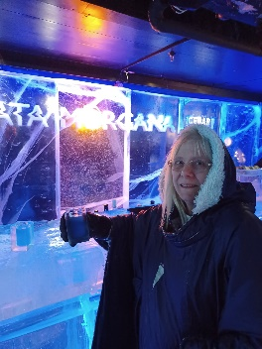
Whilst you were all sweltering at the beginning of September, Jon and I were enjoying our post-“Summer of Hope” Challenge break – a cruise (needless to say) to the islands and archipelagos of Sweden. The weather was very kind to us (low twenties, no rain) and our visit to the Ice Bar in Stockholm was a big hit – you were needing lots of ice cubes in your drinks to cool down, we were drinking ours out of giant ice-cube “glasses” at -15ºC…

I came back to the usual large number of emails, plus deadlines for “Roundabout”, branch visits, Zoom meetings, etc. I’m not complaining, though, as I am getting so much out of serving God and the members of MU across Chelmsford Diocese.

Then there was the Annual Gathering in York…

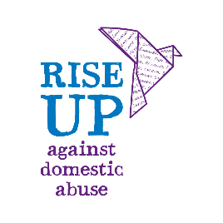
What a wonderful, jam-packed day. The usual rousing message from Sheran, our WWP, assured us we are moving on with our “Transformation – Now!” theme and showing “Transformation in Action”.

The Annual Review was launched and summarised and is available for all to download from https://mothersuniononline.org/1I8Y-8EAKF-WU7P6L-59F0SH-1/c.aspx – do have a look and see that MU made a difference to the lives of a whopping 3.4million people worldwide in 2022 – how amazing is that?!

Two new initiatives were also launched – “Building Bridges” clergy support and engagement guide and RISE UP Against Domestic Abuse which is MU’s new campaign to raise awareness about domestic abuse 365 days a year in addition to the 16-days of Activism in November and December.

The letters RISE UP (always in capitals) stand for Respond, Inform, Support, Empower, Unite and Pray. Its aims are not to turn us all into domestic abuse professionals, but to help us respond appropriately to a disclosure and ensure we know where to sign post a victim to. You will hear lots more about this in the coming months, but to get a taste of what it’s all about, have a look at RISE UP Against Domestic Abuse | Mothers' Union (mothersunion.org)

When the official proceedings had ended, we had a leisurely walk to York Minister from The Barbican Centre and were just enjoying an ice-cream whilst we waited for the doors to open, when the heavens opened instead and within minutes we were soaked through cowering under umbrellas and juggling ice cream in the spare hand! From the sublime to the ridiculous… 700 drowned rats were eventually admitted into the Minister to enjoy Evensong as we dried out. Archbishop Stephen was much the same as when he was our Bishop and spoke fondly of all things MU – aahh!

Your prayers will be appreciated as I move on to write my message for “Roundabout” in which I will try to not be too repetitive of the newsletter messages plus giving some more in-depth feedback on the Annual Gathering.

“Creator-God, Come fill me with creativity, and breathe new inspiration into my heart, soul, mind, and strength. Help me be like you and reflect your innovation and artistry in the world. Be my inspiration, God, and guide me to fresh and new ideas. Amen”

Love and blessings. Maxine x

PS. It’s not too late to add to my “Summer of Hope” Challenge sponsorship at https://www.justgiving.com/page/maxine-paul-1687445214184 Thank you x

English for Women fundraising concert: Two Lads and a Laptop
Tickets for our diocesan fundraising concert on 7th October can still be ordered online at Live at Emmanuel: Two Lads and a Laptop! – revPACman or by contacting Diocesan Treasurer Tricia, VP Merrill Knight, or Secretary Kathryn Booth. Anyone is welcome so please encourage your friends and neighbours to come along – it promises to be a wonderful evening.

AGM – 13th November
Our AGM is scheduled to take place on 13th November. The Bishop of Barking, Bishop Lynne Cullens will be leading the service in the Cathedral from 10:30 before we move to the Chapter House for refreshments and our AGM and Council. Please let Secretary Kathryn know if you or any of your members are planning to attend. If you would like to order diaries, planners, calendars or cards for collection at Council then please email muerep@muchelmsford.org.uk. Please contact lynda.michael.booth@btinternet.com to order any certificates or badges.

New diocesan constitution
Thank you to all those who have provided feedback on the draft of our updated constitution. Trustees will be discussing this at their next meeting. The Constitution will then be presented for adoption at our AGM on 13th November.

Prisons Week (8th-14th October)
Prisons week is a week of prayer which aims to raise awareness about the needs of the prison population, encourage people to volunteer their time, and enable individuals and churches to pray for the needs of all those affected by prisons. Mothers’ Union members have a presence in many of the 133 prisons throughout Britain and Ireland and give their time and gifts in many different ways, including by sending cards, providing release bags, and supplying toys and craft materials for visitor centres and prison creches. The prisons week prayer guide and campaign film are available on www.prisonsweek.org. Throughout the week we will be posting prayers and information on our Facebook page, website and Whatsapp groups.

Lord you offer freedom to all people. We pray for those in prison. Break the bond of fear and isolation that exist. Support with your love prisoners and their families and friends, prison staff and all who care. Heal those who have been wounded by the actions of others, especially the victims of crime. Help us to forgive one another, to act justly, love mercy and walk humbly together with Christ in his strength and in his Spirit, now and every day. Amen.
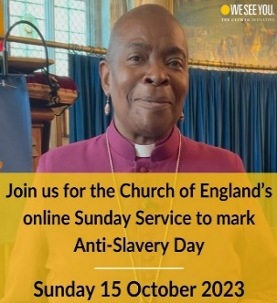
Anti-Slavery Day (18th October)
This year for anti-slavery day, the Clewer Initiative has launched the “Do One Thing” campaign to encourage groups and individuals to take further steps towards eliminating modern slavery and exploitation in Communities. On 15th October the Church of England will be holding an online service for Anti-Slavery Day focussed on the link between modern slavery and refugees. Find out more at https://theclewerinitiative.org

News from Mary Sumner House
For regular updates on central MU work, sign up to the central e-newsletter on this link: https://mothersuniononline.org/p/1I8Y-G0K/sign-up-to-the-mothers-union-mailing-list

The latest edition of “Connected” magazine is arriving this week and next. If any members have not received their copy then please contact Secretary Kathryn who will follow this up.

Dates for the dairy

- Two Lads and a Laptop concert: 7th October 7pm, Emmanuel Church, Billericay. 7pm
- AGM and Council: 13th November, Chelmsford Cathedral 10.30am

